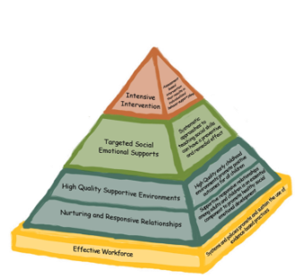
Emotions &
Emotional-Regulation
Implementation Guide Checklist
Name:___________________________________________________ Date:___________________
Program Name:_______________________________________________________________________
Early Childhood Positive Behavior Supports for Family Child Care (EC-PBIS FCC) is based on the pyramid model of best practices for encouraging social emotional competence in young children. In programs that have implemented pyramid model practices children have significantly increased social skills and decreased challenging behavior.
This checklist encourages reflection on pyramid model practices used in your program. Once you have completed the checklist you are encouraged to call your consultant to set up a time to discuss how to use this information and what supports are available to you.
- Identification and Labeling of Emotions
- Do you label or prompt children to label their emotions throughout the day?
- Rarely | - Sometimes | - Frequently
- Do you assist children in recognizing and understanding emotions in peers by pointing out facial expressions, voice tone, body language or words?
- Rarely | - Sometimes | - Frequently
- Do you use real-life situation to practice identification of emotions? (i.e. use moments that happen everyday and label those emotions)
- Rarely | - Sometimes | - Frequently
- Do you use a variety of strategies to teach children emotion/feeling words?
- Rarely | - Sometimes | - Frequently
- Do you model appropriate expressions and labeling of your own emotions and self-regulation throughout the day? (i.e. Tell the children, “I’m feeling frustrated right now so I’m going to take 3 deep breaths to help me calm down.”)
- Rarely | - Sometimes | - Frequently
- Do you validate children’s emotions by labeling them and if developmentally appropriate helping children talk about their emotions?
- Rarely | - Sometimes | - Frequently
- Do you individualize instruction for children having difficulty identifying, understanding and expressing their emotions?
- Rarely | - Sometimes | - Frequently
- Characteristics that Foster Emotional Literacy
- Do you have books available that portray various emotions?
- Rarely | - Sometimes | - Frequently
- Do you have photographs, pictures and posters that portray people in various emotional states?
- Rarely | - Sometimes | - Frequently
- Do you have other materials to support emotional literacy? (songs, feelings chart, feelings wheel, etc.)
- Rarely | - Sometimes | - Frequently
- Do you have at least one place for children to go to be by themselves?
- Rarely | - Sometimes | - Frequently
- Promoting Children’s Individual Emotional Regulation
- Do you respond immediately to children in distress to assess the child’s status?
- Rarely | - Sometimes | - Frequently
- Do you help children recognize cues of emotional escalation? (e.g. verbally labeling, using the relaxation thermometer) What words do you use?
- Rarely | - Sometimes | - Frequently
- Do you teach techniques and have tools to help children regulate their emotions? (e.g. relaxation thermometer, Tucker Turtle story, counting to three, deep breaths)
- Rarely | - Sometimes | - Frequently
- Do you offer opportunities for children to practice handling strong emotions? Can you think of examples?
- Rarely | - Sometimes | - Frequently
- Do you offer opportunities for children to practice emotional regulation skills at times when they are not having strong emotions? Why is this important?
- Rarely | - Sometimes | - Frequently
- Do you recognize emotional escalation and intervene early to provide guidance?
- Rarely | - Sometimes | - Frequently
- Do you practice relaxation strategies with children? (e.g. yoga, breathing, going to “be by myself” spaces)
- Rarely | - Sometimes | - Frequently
- Do you provide positive acknowledgement of children’s expression of emotion and attempts at self-regulation?
- Rarely | - Sometimes | - Frequently

Next Steps:
- Make a list of the top 2 or 3 items you would like to work on
- Call your consultant

