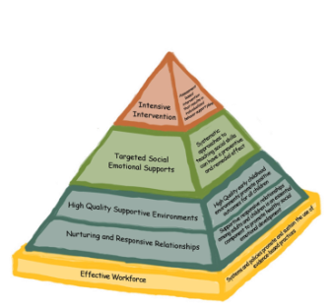
Friendship &
Problem Solving
Implementation Guide Checklist
Name:___________________________________________________ Date:___________________
Program Name:_______________________________________________________________________
Early Childhood Positive Behavior Supports for Family Child Care (EC-PBIS FCC) is based on the pyramid model of best practices for encouraging social emotional competence in young children. In programs that have implemented pyramid model practices children have significantly increased social skills and decreased challenging behavior.
This checklist encourages reflection on pyramid model practices used in your program. Once you have completed the checklist you are encouraged to call your consultant to set up a time to discuss how to use this information and what supports are available to you.
- Friendship Skills
- Are opportunities for peer interaction embedded in daily routines and activities? (e.g. children have enough free play time where they can engage in play together)
- Rarely | - Sometimes | - Frequently
- Do you use positive descriptive comments to acknowledge children who are working together, helping each other or engaging in other friendship behaviors?
- Rarely | - Sometimes | - Frequently
- Do you intentionally teach friendship skills such as: sharing, taking turns, being helpful, etc?
- Rarely | - Sometimes | - Frequently
- Do you use a variety of strategies to teach friendship skills (role playing, discussion, visual prompts, modeling, acknowledgement/encouraging)?
- Rarely | - Sometimes | - Frequently
- Do you individualize how you teach children to initiate and respond to their peers?
- Rarely | - Sometimes | - Frequently
- Do you encourage children to play together?
- Rarely | - Sometimes | - Frequently

- Do you prepare the environment to encourage interactions (e.g. toys that require 2 or more children, interest areas that have space for a few children at a time)
- Rarely | - Sometimes | - Frequently
- Do you structure activities to encourage interactions including peer partners/buddies?
- Rarely | - Sometimes | - Frequently
- Do you provide individualized assistance to help children initiate or maintain interactions with their peers?
- Rarely | - Sometimes | - Frequently
- Do you sometimes refer children to each other instead of adults for assistance?
- Rarely | - Sometimes | - Frequently
- When developmentally appropriate do you support children in reflecting on interactions with their peers, having the children doing most of the talking?
- Rarely | - Sometimes | - Frequently
- Do you model friendship skills in interactions with children or other adults?
- Rarely | - Sometimes | - Frequently
- Problem Solving
- Do you systematically teach problem-solving steps using visuals?
- Rarely | - Sometimes | - Frequently
- Do you provide visual cues and tools for the children to use in learning to problem-solve? (the “Solutions Kit”, Tucker Turtle story, other scripted stories)
- Rarely | - Sometimes | - Frequently
- Do you individualize instruction on problems solving based on children’s developmental level and individual needs?
- Rarely | - Sometimes | - Frequently
- Do you use problem solving in interactions with children and model problem solving steps?
- Rarely | - Sometimes | - Frequently

Next Steps:
- Make a list of the top 2 or 3 items you would like to work on
- Call your consultant

