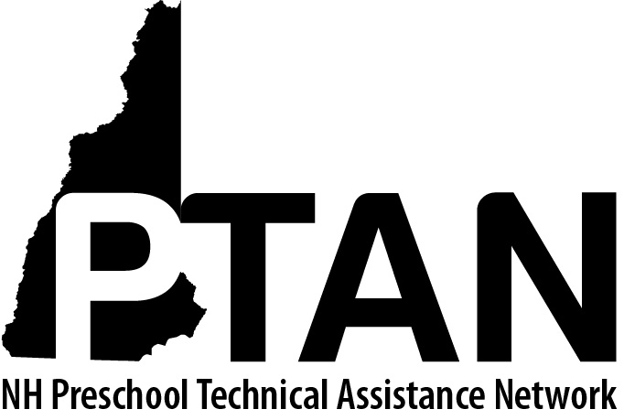
NH Preschool Technical Assistance Network
SERESC, 165 South River Road, Bedford, NH 03110 • 603-206-6800 • http://ptan.seresc.net/
Joan M. Izen, MA, CCC/SLP, Project Director

Child Care Consultant Position Requirements

The Project Director will assure that all consultants working on this contract are fully qualified.

- All consultants will hold, at minimum the CDB Early Childhood Master Professional Credential with the Program Consultant or Allied Professional Endorsement.

- All consultants will submit a current resume, including notation of their Early Childhood Credential as well as education and relevant work experience.
- MA or MS in early childhood education or related field preferred
- Previous experience in the areas of consulting, coaching, mentoring, student supervision and/or training required

- The Project Director will interview all interested candidates for the role of Child Care Consultant to assure that their experience and expertise qualifies them for participation on this contract.

- Qualified consultants will have expertise in the areas of:
- Early childhood education and/or early childhood special education
- Family- and center-based child care
- Early childhood mental health
- Trauma-informed Early Childhood Services (TIECS)
- Developmentally appropriate practices
- Culturally competent practices
- Evidence based practices that promote the development of social-emotional competence
- The Pyramid Model
- Behavior intervention strategies that promote pro-social skill development
- Parent communication
- Administration of the Ages and Stages Questionnaire, Child Development and Social-Emotional

- Qualified consultants will have knowledge in the areas of:
- NH Child Care Licensing Rules
- NH Early Childhood Professional Development System
- NH Early Learning Standards
- NH programs and services for young children with special needs and their families including:
- Family Centered Early Supports and Services
- Preschool special education
- Early childhood mental health
- Child care consultants will have access to a computer with email capability and word processing software (preferably Microsoft Word). At minimum, qualified consultants will be able to:
- Send and receive email
- Send and receive electronically documents as attachments
- Access websites to research resources that support their consultation

- Qualified consultants will agree to uphold the Project’s guiding principles that:
  - Children are capable individuals.
  - Behavior is a form of communication.
  - Describing behaviors and feelings is a more effective support to children than labeling them.
  - It is the teacher’s role and responsibility to teach children positive (pro-) social skills.
  - Time out is not an effective behavior management strategy because it doesn’t teach children pro-social skills.
  - Change in child behavior depends on change in the teacher’s behavior.
  - PTAN Child Care Inclusion Consultants model respect and active listening in all interactions.
  - Reflective consultation is a form of professional development that has direct, positive impact on children’s behaviors.
  - Consultation is most effective when it is requested not mandated.
  - Establishing a strong consultative relationship with teachers and administrators is key to having a positive impact on children’s behaviors.

- Consultants agree to regular participation in monthly TIECS reflective practice Zoom calls and quarterly consultant cohort meetings.

