Choosing a Practice-Based Coaching Format
for the Implementation of Pyramid Model Practices

Practice-Based Coaching (PBC) is a cyclical process for supporting teachers’ (“practitioners’”) use of effective teaching practices that lead to positive social-emotional outcomes for children.
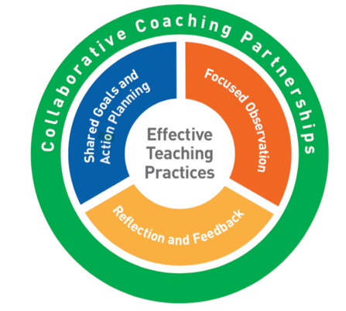
PBC occurs in 2-week cycles within the context of a collaborative partnership. Each cycle includes the following components:
- Planning goals and action steps
- Engaging in focused observation
- Reflecting on and sharing feedback about teaching practices.

There are three PBC delivery methods or formats to consider:
- Expert coaching (Individual or Team)
- Group coaching
- Reciprocal Peer coaching (Peer-to-Peer)

The leadership team will decide how coaching will be delivered and whether it will be delivered on-site, using technology, or a mix of methods. In all formats, a coach is needed to guide the PBC process, provide support, and monitor implementation and outcomes. Regardless of format, all components of PBC should be implemented which will require training for coaches and practitioners, resources, time and administrative support.

Choosing a Practice-based Coaching Delivery Format
Required Elements | Expert | Reciprocal Peer | Group
Need for individualized support. | X
Sufficient resources and time to support an expert coach. | X |  | X
A mentor or expert coach to guide the process. |  | X
A clearly defined set of evidenced-based practices | X | X | X
Self-motivated, self-sufficient, reflective practitioners. |  | X
Willingness to collaborate. |  | X | X
Access to materials, information and training. | X | X | X
Release time for the practitioners. | X | X | X
Private meeting space. | X | X | X
Video capability. | X | X | X

