Choosing Expert Practice-Based Coaching: Individual or Team

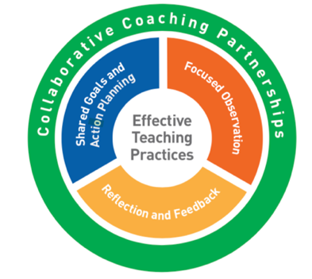
Most research on Practice-Based Coaching (PBC) has focused on the expert coaching format. This model can be used with a single teacher (“practitioner”) or a teaching team of two practitioners working together in the same classroom.

As with all PBC formats, expert coaching occurs within the context of a collaborative partnership and occurs in 2-week cycles. Both individual and team expert coaching follow the same format. For team coaching the teaching team may consist of:
- Two co-lead teachers working in the same classroom
- A lead teacher and associate or assistant teacher working in the same classroom
- A lead teacher and paraprofessional working in the same classroom

The teaching team meets together with the expert coach to proceed through the PBC cycle developing a single action plan focused on one practice they work on together. The coach completes one observation of the team and provides feedback to both practitioners during the coaching meeting.

The time requirements are identical for both individual and team expert coaching:
- The coach requires 2-3 hours for each 2-week coaching cycle (approximately 6-hours/month) to implement all aspects of expert PBC
  - The coach meets with the practitioner(s) for approximately 1-hour every other week. This meeting includes reflection, feedback, shared goals and action planning
  - The coach observes the practitioner(s) in his/her/their classroom (or via video) for approximately 1-hour every other week
  - The coach will require additional time during each coaching cycle for research of resources, preparation for meetings, completion of required documentation, communication with the practitioner(s) and scheduling

Choose the expert PBC format if you have:
- Practitioners who are interested in and committed to implementing Pyramid Model practices with fidelity
- Practitioners who want individualized, strength-based, professional development in context.
- Sufficient administrative support, staffing and funding to support the model
- Reliable and sufficient release time for the practitioner(s) to participate in regular coaching meetings
- Private meeting space
Choose the team expert PBC format if you have:
- Two practitioners teaching together in the same classroom who are both interested in and committed to implementing Pyramid Model practices together

