Choosing Group Practice-Based Coaching

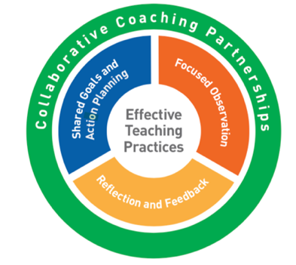
Group coaching provides the opportunity for 6-8 teachers (“practitioners”) to support one another in the implementation of Pyramid Model practices.

As with all PBC formats, group coaching occurs within the context of collaborative partnerships and occurs in 2-week cycles.

Below are the important elements that distinguish this PBC format:
- A group of 6-8 practitioners who:
  - Have completed training in the Pyramid Model practices
  - Are open to giving and receiving feedback within their group
  - Are committed to working collaboratively with group members to improve their practices
- For each cycle, all group members agree to focus on one practice; each practitioner uses this practice to create their own action plan. All members:
  - Participate in a 90-minute meeting each coaching cycle (twice a month)
  - Record and review video (a video clip, or clips) of implementing the identified practice
  - Reflect on their use of the practice as they identified on their action plan
  - Complete a reflection form
  - Occasionally meet individually with the skilled facilitator to prepare a presentation for the group
- A skilled facilitator works with the group and individual practitioners to support the group PBC process:
  - Facilitates a 90-minute group session for each coaching cycle
  - Delivers a content segment each meeting
  - Meets with 1 practitioner each cycle for approximately 1-hour to reflect with and prepare her/him for a group presentation
  - Plans content and researches resources (approximately 2-hours per cycle)
  - Communicates with group members and schedules logistics (approximately 30 minutes/cycle)
  - Additional time may be needed at start up to complete contracts, confirm technology, determine meeting time and location, establish relationships and review the facilitation guide

There are many benefits to group PBC including:
- Practitioners build feedback skills through multiple opportunities to practice giving and receiving feedback to improve their teaching practices
- Practitioners build self-reflection skills; each group member has the opportunity to focus on their own practices through review and reflection of video clips with support from the skilled facilitator
- The group process is clearly defined; the first 3 sessions are scripted
- The roles of the group members and skilled facilitator are clearly defined
- Content delivery is built into each session, pre-scripted with links to coordinated video clips; more in-depth concepts are planned and developed for the skilled facilitator to present

Choose Group Coaching if you have:
- A group of 6-8 collaborative, motivated practitioners who are committed to the coaching process and implementation of Pyramid Model practices with fidelity
- A skilled facilitator who can deliver content and guide the practitioners in the group coaching process
- Access to the required group coaching materials and information
- Administrative support for sufficient and consistent release time for all practitioners to meet and complete their group coaching responsibilities
- Private meeting space
- Video capability

