Choosing Reciprocal Peer Practice-Based Coaching

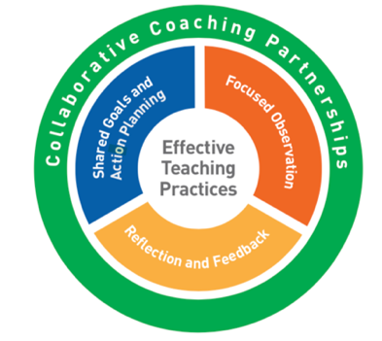
Reciprocal Peer Practice-Based Coaching (PBC) occurs when two teachers (“practitioners”) coach each other to implement Pyramid Model practices. This format is also referred to as Peer-to-Peer PBC.

As with all PBC formats, reciprocal peer coaching occurs within the context of a collaborative partnership and occurs in 2-week cycles.

Below are the important elements that distinguish this PBC format:
- Two practitioners who:
  - Have participated in training on the reciprocal peer coaching process and have received all the required materials to guide the process
  - Have participated in training on the Pyramid Model practices
  - Have approximately the same level of knowledge and experience with implementing the practices
  - Are working with children in the same age group (i.e. infants/toddlers vs. preschoolers)

This format requires that the two practitioners have sufficient ‘release time’ to participate in all aspects of the coaching cycles including:
- Meeting time (approximately 1-hour) every other week to reflect, share feedback and develop action plans
- Time to observe their peer partner implementing the teaching practices in classroom or via video (approximately 1-hour every other week)
- Planning time for observations and coaching meetings
- Time to research/request resources related to the teaching practices

Reciprocal peer PBC requires that a mentor coach or expert coach is available to support the peer partners. The mentor or expert coach guides the process and meets with the peers periodically to address questions and guide next steps.

Choose reciprocal peer coaching if you have:
- Two collaborative, motivated practitioners who are at approximately the same level of knowledge, experience with the teaching practices, and working with a similar age group
- Practitioners who agree to maintain confidentiality
- Access to training in the Pyramid Model practices and the reciprocal peer coaching process
- Access to the required coaching materials and information
- A mentor or expert coach be a resource to the practitioners in the reciprocal coach process
- Administrative support for sufficient and consistent release time for both practitioners
- Private meeting space

