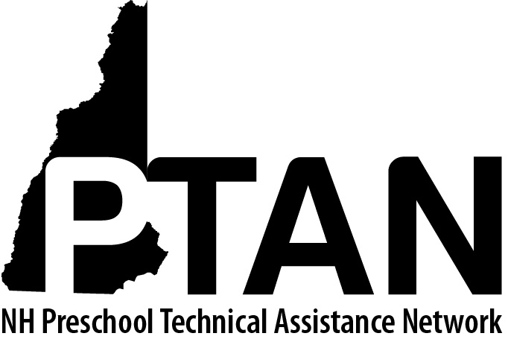
NH Preschool Technical Assistance Network
SERESC, 165 South River Rd Unit F, Bedford, NH 03110 • 603-206-6800 • http://ptan.seresc.net/
Joan M. Izen, MA, CCC/SLP, Project Director

PTAN Child Care Inclusion Project - Monthly Consultation Report

Email this report and your corresponding invoice monthly for the duration of the consultation along with any additional reports, action plans or handouts you shared with program staff (email to jizen@seresc.net and ptanprojasst@seresc.net). Please respond to all questions on this report form.

Consultant’s Name: Child Care Program Name:

Lead Teacher First and Last Name: Child’s First Name:

Document each program contact using this key:
T=telephone, E=email, OTA=onsite technical assistance, VTA=virtual technical assistance, OTR=onsite training, VTR=virtual training, R/P=research, prep or report writing

Activity Date | Activity Type  (Using key above) | Total time IN MINUTES  (1 hour=60) | Who did you consult with?  (Include First and Last names of consultees)

Briefly respond to each of the following questions:

- What were the key consultation issue(s) addressed this month?

- What recommendations did you suggest?

- What progress did you observe (child/teacher/classroom) this month?

- What strategies did you recommend to support parent involvement (including parent communication and modifying recommendations for families to use at home)?

 | Yes | No | Explanation
For all consultations:
Was the Expulsion Prevention Self-Reflection Checklist completed?

Was an action plan developed?
Does the program have an Expulsion Prevention Policy?

If yes, is the policy compliant with licensing regulations?

For child-specific consultations:
Referred to Early Supports and Services?
Referred to his/her school district for Preschool Special Education?
Referred elsewhere for evaluation or support? (If yes, where?)
Removed from the program at parents’ request? (If yes, why?)
Expelled from the program? (If yes, why?)

- Is the consultation complete? Yes No
(circle one)

- If the consultation is ongoing, what are your next steps?

