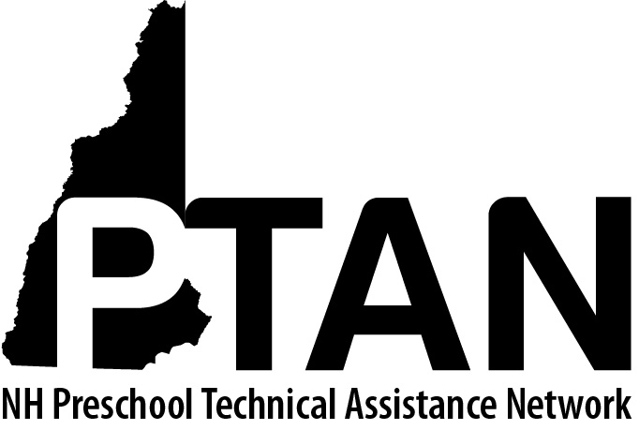
NH Preschool Technical Assistance Network
SERESC, 165 South River Road, Bedford, NH 03110 • 603-206-6800 • http://ptan.seresc.net/
Joan M. Izen, MA, CCC/SLP, Project Director

Policy for Providing Limited In-Person Child Care Consultation and Coaching

As of July 1, 2021 PTAN Child Care Inclusion Project services will offer limited in-person services, following State of NH Universal Best Practices and CDC Guidance for COVID-19 (Recommendations for Fully Vaccinated People)

- Child care programs will be offered both virtual and limited in-person consultation options
- During the intake call the Project Assistant will ask the director whether the program is allowing consultants/therapists to enter their program
  - If no, she’ll ask whether the program is open to participating in virtual consultation
    - If yes, do they have stable wireless internet and the equipment and software required for virtual consultation
  - If consultants/therapists can enter their program, she’ll ask whether there are any specific guidelines in place re: masking, social distancing, or other modifications specific to COVID
  - All information will be documented on the intake form in the “miscellaneous” section

- During the initial consultation call, the Project Director will confirm the information gathered at intake and finalize plans for consultation format

- Consultants will conduct their initial session by phone or video conference.
- Review and sign the Consultation Agreement
- Review proposed action plan and clarify as needed
- Review program guidelines re: COVID modifications
- Schedule child or classroom observation

- For programs that are allowing consultants/therapists to enter their program, observations (classroom or child-specific) will be conducted at the site, either within the classroom or outside on the playground; location to be determined collaboratively by teacher and consultant
- Prior to conducting the in-person observation, the consultant will contact the program (by phone or email) and ask whether there are any positive COVID cases at the program.
  - If yes, the observation will be cancelled and rescheduled
- The consultant will follow all COVID guidelines in place at the program
- The consultant will follow universal best practices re: mask use, sanitizing before and after entering the program and social distancing (mask use is recommended but not required)

- Reflection, feedback, and action planning will be conducted virtually or by phone with preference determined collaboratively by teacher and consultant

- All trainings will be conducted virtually July-September 2021 at which time offering in-person trainings will be reassessed in accordance with current State and CDC recommendations.

- This policy will remain in place through September 2021 at which time removing the limitations will be reassessed in accordance with current State and CDC recommendations.

