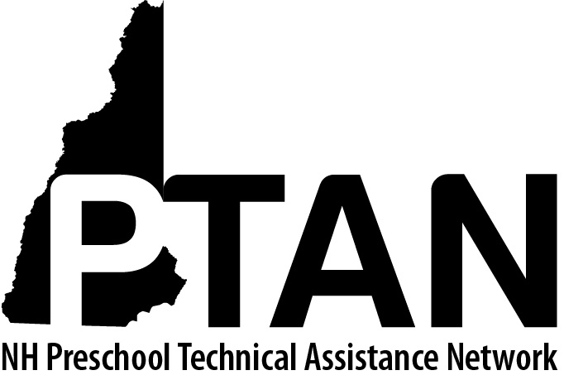
NH Preschool Technical Assistance Network
SERESC, 165 South River Road, Bedford, NH 03110 • 603-206-6800 • http://ptan.seresc.net/
Joan M. Izen, MA, CCC/SLP, Project Director

Train the Trainer: Observer Role Description

PTAN childcare consultants/trainers are invited to participate in virtual trainings as “observers” in order to build capacity of PTAN trainers to deliver content virtually to childcare teachers and directors. Observers participating in trainings agree to:

- Log onto the Zoom call 15 minutes early to check in with the trainer and clarify any questions or protocols

- Respect all information shared as confidential

- Introduce themselves as PTAN Child Care Consultants/Trainers and clearly state the purpose of their participation

- Remain silent and/or muted, except when invited by the presenter(s) to participate

- Avoid interfering in the learning experience of training participants

- Use time allotted for breakout room discussion to stay in the ‘main room’ with the presenter to ask questions or discuss the training process unless the trainer requests otherwise

- Participate in the training on a voluntary basis; no compensation will be paid for the associated time

