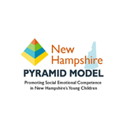

**NH PYRAMID MODEL ANNUAL REPORT 2020**

**Pyramid Model Framework:** The Pyramid Model is a proven system that supports teachers, caregivers and families to help young children develop healthy social and emotional skills that will serve them throughout their lives.

**Vision:** All New Hampshire families, early childhood programs, and communities support the social emotional well-being of young children, birth through six years.

**Mission:** The New Hampshire Pyramid Model State Leadership Team will lead the development of a sustainable, complementary state and local infrastructure for the implementation of the Pyramid Model framework.

**Recommended Outcomes:**

1. A sustainable, complementary infrastructure to support Pyramid Model statewide is implemented and monitored.
2. NH early childhood education and care workforce has the capacity to implement Pyramid Model practices with fidelity.
3. Early childhood programs statewide have access to high fidelity Pyramid Model trainers and coaches.
4. NH has a statewide cadre of high-fidelity program-wide and community-wide implementation sites.
5. Families are engaged across all levels of the system to enhance skills and strategies to support children’s social emotional well-being.
6. Programs that engage in program-wide PM implementation demonstrate increased children’s pro-social skills and reduced challenging behaviors.

**The NH Pyramid Model State Leadership Team (NH PMSLT)** includes individuals who represent government agencies and community partners invested in the well-being of children and families. The NH PMSLT meets regularly to build a statewide sustainable implementation model.

*Logos from each member of the Pyramid Model State Leadership Team organizations have been used to represent the NH PMSLT but do not indicate endorsement of this report.*





**Early Childhood Programs Implementing PM**





**Institutes of Higher Education**









**NH Pyramid Model State Leadership Team**





**Community**

**Coalitions**

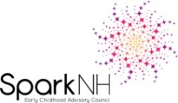

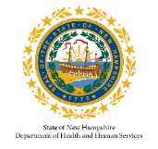





**NH PMSLT Workgroups:**

In 2019-2020, workgroups were established to focus on specific elements of the infrastructure: implementation sites, data and evaluation, professional development and marketing. Workgroup members include NH PMSLT members and other experts in the field. All workgroup efforts are aligned with the SLT vision and mission and promote achievement of the recommended outcomes. Key accomplishments of the workgroups are outlined below.



**Core Team and Infrastructure Workgroup**

* Identified & secured funding and resources to support infrastructure development
* Developed the framework and potential funding to support a Statewide Pyramid Model Coordinator position



**Data and Evaluation Workgroup**

* Worked to align the iSocial and NH PMSLT logic models to promote the development of a unified system
* Facilitated the agreement that the iSocial data system serve as the basis for statewide PM data collection and evaluation

**Implementation Sites Workgroup**

* Developed strategies to expand the number of implementation sites in NH with a focus on responding to the unique needs of childcare programs
* Recommended approaches for the incorporation of Pyramid Model language and expectations in relevant State agency contracts

**NH Pyramid Model State Leadership Team**









**Communication and Public Relations Workgroup**

* Collaborated with iSocial to create, publish and disseminate marketing materials that educate families and professionals about Pyramid Model
* Developed social media opportunities for disseminating Pyramid Model information, resources and training opportunities

**Professional Development Workgroup**

* Led the efforts to create New Hampshire’s first Pyramid Model Master Cadre

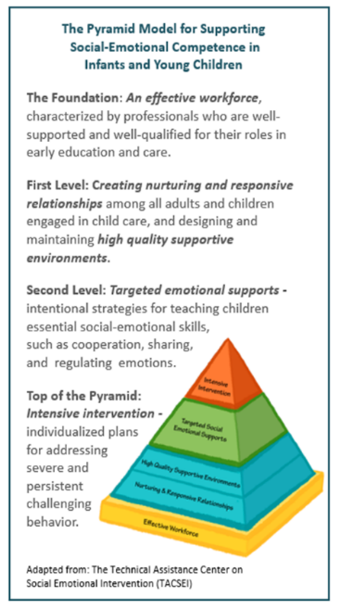

**Quotes from State Leadership Team Members**

“It has been exciting to see the strong interest among early childhood higher education faculty in integrating Pyramid Model content into their college courses. This helps to prepare our next generation of early childhood teachers and leaders to implement Pyramid Model practices to nurture young children's social and emotional development.” –Dr. Pat Cantor, Professor, Early Childhood Studies, Plymouth State University

“I was excited when NH officially became the national Pyramid Model Consortium’s 28th Pyramid Model state in 2016. I’m even more excited now that there is a great deal of enthusiasm for the model across the early childhood community, as well as dedicated funding for system coordination and infrastructure building to help us move from vision to reality.“ -Debra Nelson, Bureau Chief, Child Development and Head Start Collaboration, DHHS/Division of Economic & Housing Stability

**LEARN MORE: Follow us on Facebook, NH Pyramid Model**

The Pyramid Model Consortium: [**www.pyramidmodel.org**](http://www.pyramidmodel.org)

The National Center for Pyramid Model Innovations: [**www.challengingbehavior.org**](http://www.challengingbehavior.org)

NH DOE iSocial [Improving social-emotional outcomes of infants, toddlers and young children with disabilities (birth to age 5) in NH]

[**https://sites.google.com/education.nh.gov/isocial/home**](https://sites.google.com/education.nh.gov/isocial/home)

Created February 2020

This report was made possible by the Preschool Development Grant (U.S. Department of Health and Human Services, Administration for Children and Families, grant number 90TP0060). Its contents are solely the responsibility of the authors and do not necessarily represent the official view of the

United States Department of Health and Human Services, Administration for Children and Families.