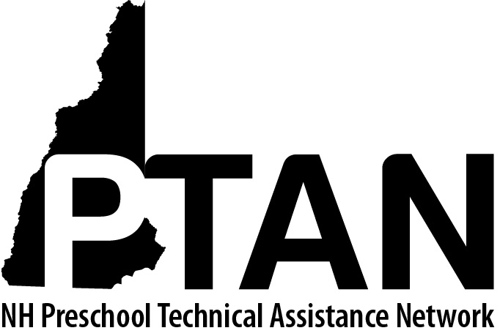
NH Preschool Technical Assistance Network
SERESC, 29 Commerce Drive, Bedford, NH 03110 • 603-206-6800 • http://ptan.seresc.net/
Joan M. Izen, MA, CCC/SLP, Project Director

Date:

Dear Parent or Guardian,

I am writing to ask your permission to have a consultant from the PTAN Child Care Inclusion Project help us better respond to your child’s needs when he attends our program. PTAN is a grant-funded project that provides free consultation and training to New Hampshire childcare programs. More information about PTAN, including the project’s belief statements is available on the website: http://ptan.seresc.net. You may also call the project directly (603-206-6800) with specific questions.

The PTAN consultant will come to our program on one or several occasions to observe your child during classroom activities so that she can help us work more successfully with him/her. It is important for you to know that the PTAN consultant will not be evaluating or working directly with your child. The purpose of the consultation is professional development, to help us develop new strategies and skills that will in turn help your child. All information about your child and family will remain confidential.

We look forward to sharing with you what we learn through the PTAN consultation; some may be helpful strategies you can use at home too! Please sign or initial this letter to indicate your permission and return to me as soon as possible.

Sincerely,

Teacher or Director Name
Program Name

I understand that my child’s teacher will be working with a PTAN consultant to support her ability to work more successfully with my child. I give my permission for the consultant to observe my child during classroom activities.

_____________________________________________________________________________
Parent Signature or Initials

