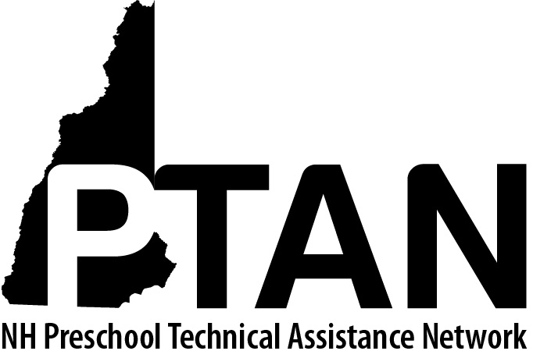
NH Preschool Technical Assistance Network
SERESC, 165 South River Road, Bedford, NH 03110 • 603-206-6800 • http://ptan.seresc.net/
Joan M. Izen, MA, CCC/SLP, Project Director

PTAN Child Care Inclusion Project
Consultation Agreement: Consultant – Teacher - Director

The completed signature page of this document (page 3) indicates that the consultant, teacher and director have carefully reviewed and are in agreement with all items.

Consultant:
As I work with you to develop and implement strategies that promote successful inclusion in your classroom I, the consultant, agree to:

- Be punctual and organized.

- Provide consultation that is:
- Responsive to your needs
- Respectful of you, your program, the children and families
- Focused on research and evidence-based teaching practices, in the context of a collaborative partnership
- Focused on successfully including the child in your program (preventing suspension and expulsion)

- Provide additional support by:
- Sharing resources
- Providing models of research and evidence-based teaching practices
- Watching, listening, and learning from you about your educational beliefs and values
- Focusing on your strengths, your emerging skills, and your individual professional goals
- Directing you to resources as needed to support your participation in virtual consultation sessions and/or your collection of video for classroom observations

- Support your program in developing (or revising) an expulsion policy that is at a minimum compliant with the 2017-2027 NH Child Care Licensing Rules.

- Maintain confidentiality regarding the consultation specific to the director and teacher(s) involved, except in instances related to my responsibilities as a mandated reporter. I will document general aspects of the consultation process in my monthly reports and may discuss aspects of the consultation with my colleagues and Project Director to gather ideas, resources and insights. Anything discussed with my consultant colleagues will be kept confidential by all participants.

- Comply with NH RSA 169-C Child Protection Act which legally mandates the reporting of any suspected child abuse or neglect. If, in the process of my consultation I become aware of any child abuse or neglect, I will work with the child’s teacher(s) and Director to support their prompt reporting to DCYF Central Intake. If the teacher and Director refuse to report I will be obligated to make the report to DCYF.

- Other agreement(s):

Teacher:
As I work to promote successful inclusion in my classroom, I the teacher, agree to:

- Be punctual.
- Make every effort to attend all scheduled virtual meetings at the agreed upon time.
- Notify the consultant of a cancellation within 24 hours of the scheduled meeting or as soon as possible

- Work with the consultant to clearly identify, establish and work toward goals that support a child’s (or children’s) continued participation in my classroom.

- Share my action plan(s) with my director or supervisor so that he/she can support me with the time and resources needed.

- Be present and actively participate in all consultation meetings by:
- Assessing my strengths and needs
- Asking questions
- Sharing pertinent information
- Reflecting and listening
- Giving my consultant feedback about how our partnership is working and offering suggestions for making it more effective.

- Be open to being observed and receiving feedback.

- Be open to learning new strategies and changing my practices as needed to support the child (or children).

- Be open to collecting and sharing video (or livestreaming) for classroom observations if circumstances demand it.

- Regularly assess my progress towards the identified goals and communicate with my consultant.

- Comply with NH RSA 169-C Child Protection Act which legally mandates the reporting of any suspected child abuse or neglect. If I become aware of any child abuse or neglect, I will work with my Director and the consultant to ensure prompt reporting to DCYF Central Intake (1-800-894-5533 24 hours/day).

Director:
As I support the inclusion of ALL children in my program I, the Director, agree to:

- Provide the teacher(s) participating in consultation the time, private space, resources, access to a computer for video conferencing if needed (and associated technology support) and classroom coverage as needed.
- Support the teacher to be available to participate in all scheduled virtual meetings at the agreed upon time
- Ensure that the consultant is notified of a cancellation within 24 hours of the scheduled meeting or as soon as possible

- Work with the consultant to write, or revise program policy that meets or exceeds the childcare licensing rule that “addresses the limitations of expelling children from the childcare program for challenging behaviors”.

- Make every effort to maintain in the program the child for whom consultation was requested.

- Respect the confidentiality of the consultation relationship.

- Comply with NH RSA 169-C Child Protection Act which legally mandates the reporting of any suspected child abuse or neglect. If I become aware of any child abuse or neglect, I will ensure prompt reporting to DCYF Central Intake (1-800-894-5533 24 hours/day).

Consultation Agreement Signature Page

I, the consultant, commit to the above and to being respectful, approachable, trustworthy, and non-judgmental in all our consultation interactions to create a positive collaborative partnership that supports your professional development.

___________________________________________________________ __________________
Consultant signature Date

I, the teacher, commit to the above and to being open to suggestions, ready to ask for what I need, and willing to try to change my teaching practices. I am committed to creating a positive collaborative partnership with the consultant that supports my professional development.

___________________________________________________________ __________________
Teacher Signature Date

I, the administrator, have reviewed this agreement and will support its implementation.

___________________________________________________________ _________________
Director Signature Date

