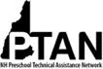
NH Preschool Technical Assistance Network
P.O. Box 1243, Concord NH 03302 • 603-865-7145 • Joan M. Izen, MA, CCC/SLP, Project Director

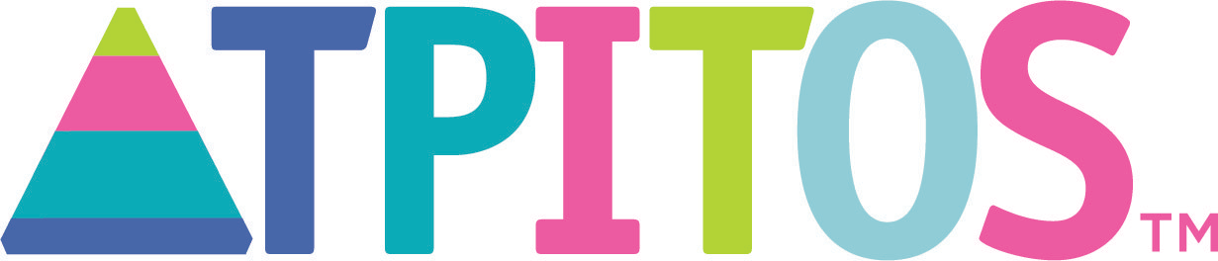

Teaching Pyramid Infant Toddler Observation Scale (TPITOS) for Infant and Toddler Classrooms
TPITOS™:
- Is a research-based assessment tool that measures implementation of teacher practices associated with the Pyramid Model for Promoting Social Emotional Competence in Young Children in classrooms serving children ages birth-3 years
- Is conducted by a trained and validated administrator
- Is intended to be an ongoing tool, not a one-time event
TPITOS™ Results:
- Provide teachers with feedback regarding their teaching practices
- Guide Practice-Based Coaching action planning
- Are NOT intended to be used for teacher evaluation
- Are NOT intended to be shared with identifying information with anyone other than the teacher and the TPITOS administrator
- May be visible in PIDS (Pyramid Model Implementation Data System) by others in your program who have designated roles in the system. Those with access to view PIDS data have an ethical responsibility to maintain the teacher’s results confidential as outlined in the site’s letter of commitment.

TPITOS™ Helps Programs:
- Support effective implementation of the evidence-based Pyramid Model practices
- Promote social-emotional competence in young children
- Implement strategies to prevent and address challenging behavior
- Compare implementation of Pyramid Model practices across classrooms, teachers, and programs
- Identify where teachers need extra professional development and support
I Can Expect my TPITOS™ Administrator to:
- Provide basic information about the TPITOS™ so that I understand the purpose and process
- Schedule on a day and time that is mutually convenient
- Conduct a 2-hour classroom observation
- Conduct a 15-30 minute interview about use of Pyramid Model practices
- Provide a strength-based feedback session to reflect on results and answer questions
- Provide me with a copy of my TPITOS™ scoring booklet
PTAN Program Coach and Trainer Becky Britton is available to support TPITOS administrators
and can be reached at beckybrittonnh@gmail.com

