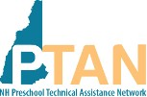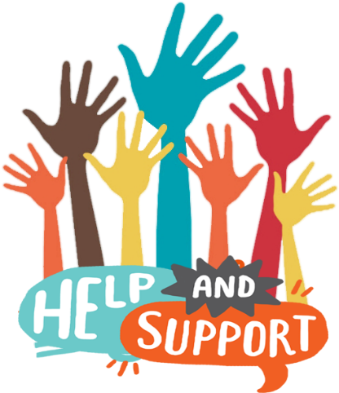
*PTAN Child Care Inclusion Project activities are financed under a contract with the State of New Hampshire, Department of Health and Human Services, with funds provided in part by the State of New Hampshire and/or such other funding sources as were available or required, e.g., the United States Department of Health and Human Services.

603-865-7145
PTANcoordinator@gmail.com

FREE* Services to Support NH Child Care Programs

The NH Preschool Technical Assistance Network (PTAN)

is a grant-funded project affiliated with the Pyramid Model Consortium.

Our primary goals are to reduce the suspension and expulsion of children whose behaviors adults find challenging and to strengthen teacher retention through individualized consultation and training. Our work is grounded in Pyramid Model evidence-based practices that support the successful inclusion of all children.

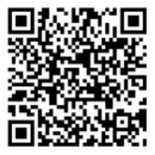

How can we help?
PTAN consultants, trainers and coaches are qualified and caring individuals with decades of experience in NH early care and education programs.

Services are individualized to meet the needs of each program and can be provided in-person and virtually.

Give us a call!
PTAN consultation is a professional development activity.
Participation is voluntary and most successful when the participating teacher is open to examining and potentially changing their practices.

603-865-7145

Contact us for
HELP!

